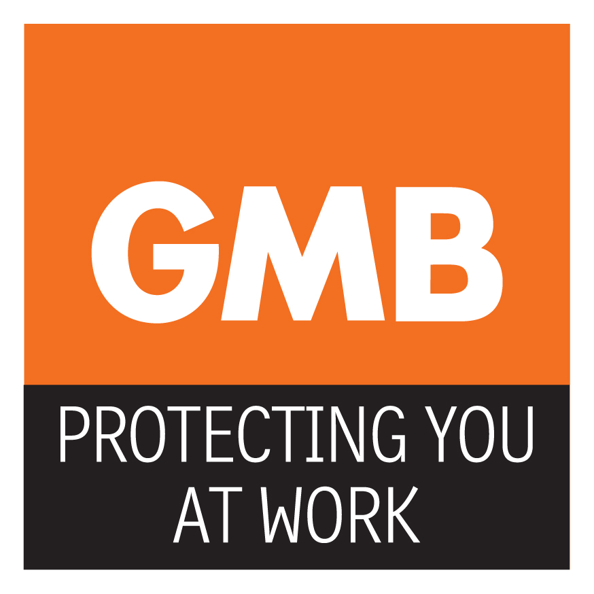

24th April 2018
NHS PAY OFFER – GMB SAY “REJECT IT”

Other NHS Unions including Unison are advising their members to accept this deal, but GMB Nationally and your local Branch are saying “reject”. This is why.

- The majority of NHS staff are already at the top of their pay band, so this proposal is a 3 year deal which equates to 6.5% in total. That is below the predicted rates of inflation, so is in real terms a pay cut; AGAIN.

- If you are not at the top of your band, it might appear to be a good deal initially; but the high percentages published are based on the employees moving up the incremental scale each year. But…

- Incremental increases are NOT AUTOMATIC.
- Progression is subject to “passing” your appraisal which has yet to be formulated.
- Without this proposal, you would have moved up the current increments anyway and there would have been an annual increase too.

This is a smoke and mirrors proposal and your Union recommends rejection.

Below are a few examples of how the REAL TIME increase will affect staff…bear in mind that the government are benchmarking the 3 year rise to the salary they were earning in March 2018 and they are not including what would be the 3 year incremental rise staff would get on the current A4C scales
BAND 2 scp 5

Salary as at March 2018……£16536 Salary on existing A4C scales as at march 2021….£18157 which is a rise over 3 years of £1621
Salary as at March 2018…..£16536 Salary on new pay scales as at march 2021………..£19337 which is a rise over 3 years of £2801
Real term rise for these staff is £2801 - £1621 = £1180 this means that, as a percentage of their old 3rd year salary, this is a rise of 6.1%

The old 3rd year salary is used because on the current scheme they would have reached this level anyway so their actual real term rise is the difference between the new salary after 3 years and the old salary after 3 years…..giving a rise of 6.1% and not the 16.94% touted by the government

Effectively when the incremental rise on the current pay scale is taken into account as compared to the incremental rise on the new scales it can be seen that the touted rises are nowhere near as generous as we are being led to believe.

This does not include what would have been the 1% cost of living rise as per the salary cap….add that in and the figures are even less

The example below is a Band 2 on SCP 5 assuming that each pay point will rise by 1% each year.

Salary at March 2018……..SCP 5 = £16536 [current]
Salary at April 2018…………SCP 6 = £17137.68
Salary at April 2019…………SCP 7 = £17876.23
Salary at April 2020…………SCP 8 = 18707.17

As can be seen a Band 2 earning £16536 in March 2018 will progress up the pay points of the current scheme and in 20/21 will earn
£18707.17 per annum.

On the new scheme in 20/21 that same Band 2 will earn
£19337 per annum.

A difference of only £629.83 in 3 years. [3.25%]

BAND 3 scp 6

Salary as at March 2018……£16968 Salary on existing A4C scales as at march 2021….£18333 which is a rise over 3 years of £1365
Salary as at March 2018…..£16968 Salary on new pay scales as at march 2021………..£21142 which is a rise over 3 years of £4174
Real term rise for these staff is £4174 - £1365 = £2809 this means that, as a percentage of their old 3rd year salary, this is a rise of 15.3%

The old 3rd year salary is used because on the current scheme they would have reached this level anyway so their actual real term rise is the difference between the new salary after 3 years and the old salary after 3 years…..giving a rise of 15.3% and not the 24.6% touted by the government

BAND 4 scp 14

Salary as at March 2018……£21263 Salary on existing A4C scales as at march 2021….£22683 which is a rise over 3 years of £1420
Salary as at March 2018…..£21263 Salary on new pay scales as at march 2021………..£24157 which is a rise over 3 years of £2894
Real term rise for these staff is £2894 - £1420 = £1474 this means that, as a percentage of their old 3rd year salary, this is a rise of 6.5%

The old 3rd year salary is used because on the current scheme they would have reached this level anyway so their actual real term rise is the difference between the new salary after 3 years and the old salary after 3 years…..giving a rise of 6.5% and not the 13.61% touted by the government

BAND 5 spc 20

Salary as at March 2018……£25551 Salary on existing A4C scales as at march 2021….£28746 which is a rise over 3 years of £3195
Salary as at March 2018…..£25551 Salary on new pay scales as at march 2021………..£30615 which is a rise over 3 years of £5064
Real term rise for these staff is £5064 - £3195 = £1869 this means that, as a percentage of their old 3rd year salary, this is a rise of 6.5%

The old 3rd year salary is used because on the current scheme they would have reached this level anyway so their actual real term rise is the difference between the new salary after 3 years and the old salary after 3 years…..giving a rise of 6.5% and not the 19.82% touted by the government

BAND 6 scp 24

Salary as at March 2018……£29626 Salary on existing A4C scales as at march 2021….£32731 which is a rise over 3 years of £3105
Salary as at March 2018…..£29626 Salary on new pay scales as at march 2021………..£33779 which is a rise over 3 years of £4153
Real term rise for these staff is £4153 - £3105 = £1048 this means that, as a percentage of their old 3rd year salary, this is a rise of 3.2%

The old 3rd year salary is used because on the current scheme they would have reached this level anyway so their actual real term rise is the difference between the new salary after 3 years and the old salary after 3 years…..giving a rise of 3.2% and not the 14.02% touted by the government

BAND 7 scp 27

Salary as at March 2018……£37777 Salary on existing A4C scales as at march 2021….£41787 which is a rise over 3 years of £4010
Salary as at March 2018…..£37777 Salary on new pay scales as at march 2021………..£44503 which is a rise over 3 years of £6726
Real term rise for these staff is £6726 - £4010 = £1869 this means that, as a percentage of their old 3rd year salary, this is a rise of 6.49%

The old 3rd year salary is used because on the current scheme they would have reached this level anyway so their actual real term rise is the difference between the new salary after 3 years and the old salary after 3 years…..giving a rise of 6.49% and not the 17.8% touted by the government

